CCl₂H₂  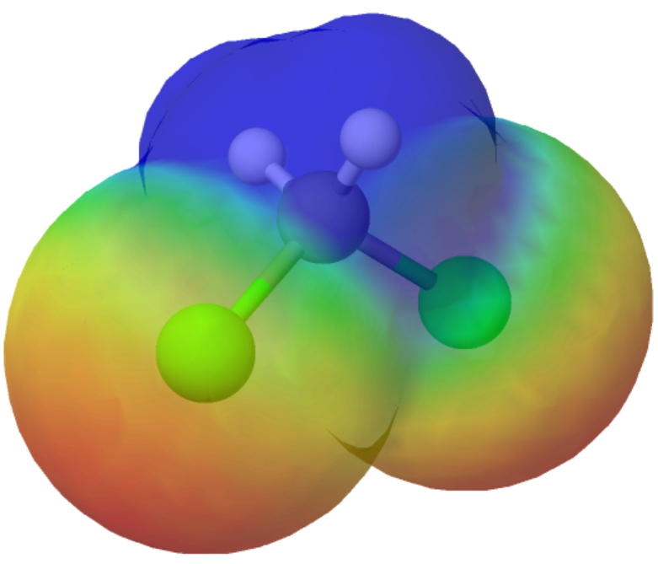 | CCl₂H₂ | CCl₂H₂
CCl₂H₂  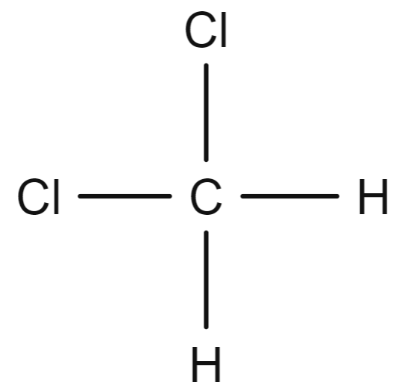 | CCl₂H₂ | CCl₂H₂
CCl₂H₂  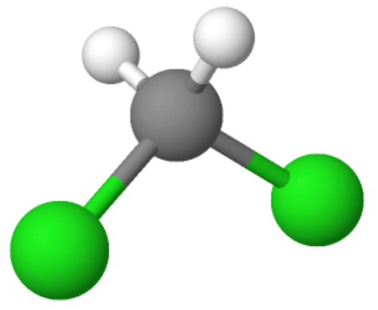 | CCl₂H₂ | CCl₂H₂

