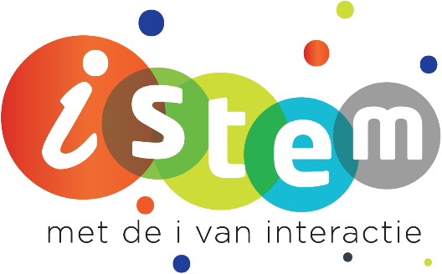

STEM Project:
Energy 2 go
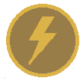 |  | 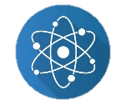
Vak:  elektriciteit | Vak:  Techniek | Vak:  Fysica | Vak:  Chemie

Links + QR codes naar de bookwidgets :

Grootheden en eenheden:
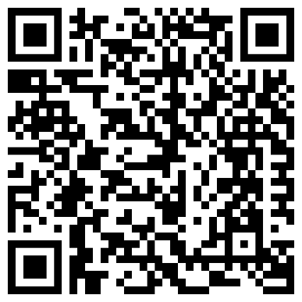
https://www.bookwidgets.com/play/s5x1JIVm-iQAE81yNggAAA/LDHD4LE/quiz-grootheden?teacher_id=5673840488218624
QR code:

Serie- en parallel schakeling:
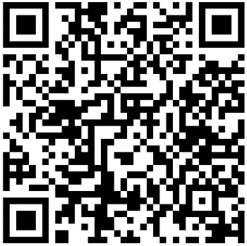
https://www.bookwidgets.com/play/cxPMgP3d-iQAErZxlQgAAA/9DG9W9F/g03-serie-en-pa?teacher_id=5472886417522688
QR code:

Windenergie :
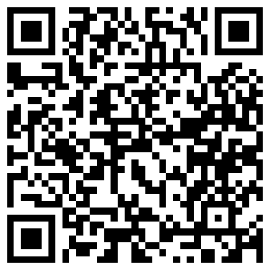
https://www.bookwidgets.com/play/jx1xELrv-iQAFqdIOQgAAA/BDG4ZBD/windenergie?teacher_id=5673840488218624
QR code :

Zonne-energie :
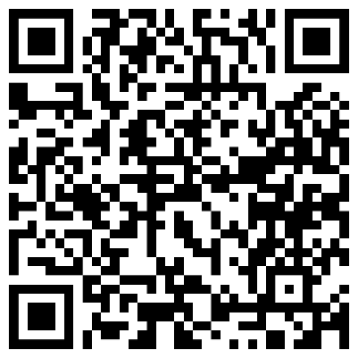
https://www.bookwidgets.com/play/jx1xELrv-iQAFqdIOQgAAA/BDG4ZBD/windenergie?teacher_id=5673840488218624
QR code:

Opslag van energie:
https://www.bookwidgets.com/play/EScx-hSS-iQAFuTVZggAAA/MDGVFMJ/opslaan-van-ene?teacher_id=5673840488218624
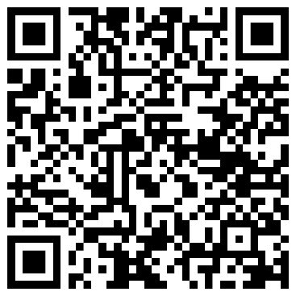
QR code:

