|  |
| --- |
| **BIJLAGEN**  **Draaiboek Escape Room**  **Moordonderzoek** |

Hierin zijn alle documenten opgenomen die nodig zijn voor de escape room.

De document zijn klaar om af te drukken.

INHOUD PER PAGINA

1. Inhoud
2. Crime scene foto’s
3. Woorddoolhof , morse code, leger alfabet uitleg
4. Secret code
5. Alibi omschrijving in morse
6. Verschillende bindingen
7. Drugslabo
8. Bindingenspel
9. Daltons elementen

|  |  |  |
| --- | --- | --- |
| Afbeeldingsresultaat voor doolhof pngAfbeeldingsresultaat voor footstep pngAfbeeldingsresultaat voor tegelvloer  **SCHOENMAAT >35** | Afbeeldingsresultaat voor doolhof pngAfbeeldingsresultaat voor footstep pngAfbeeldingsresultaat voor tegelvloer  **SCHOENMAAT >36** | Afbeeldingsresultaat voor doolhof pngAfbeeldingsresultaat voor footstep pngAfbeeldingsresultaat voor tegelvloer  **SCHOENMAAT >37** |
| **Atoom** | **Ion** | **Molecule** |

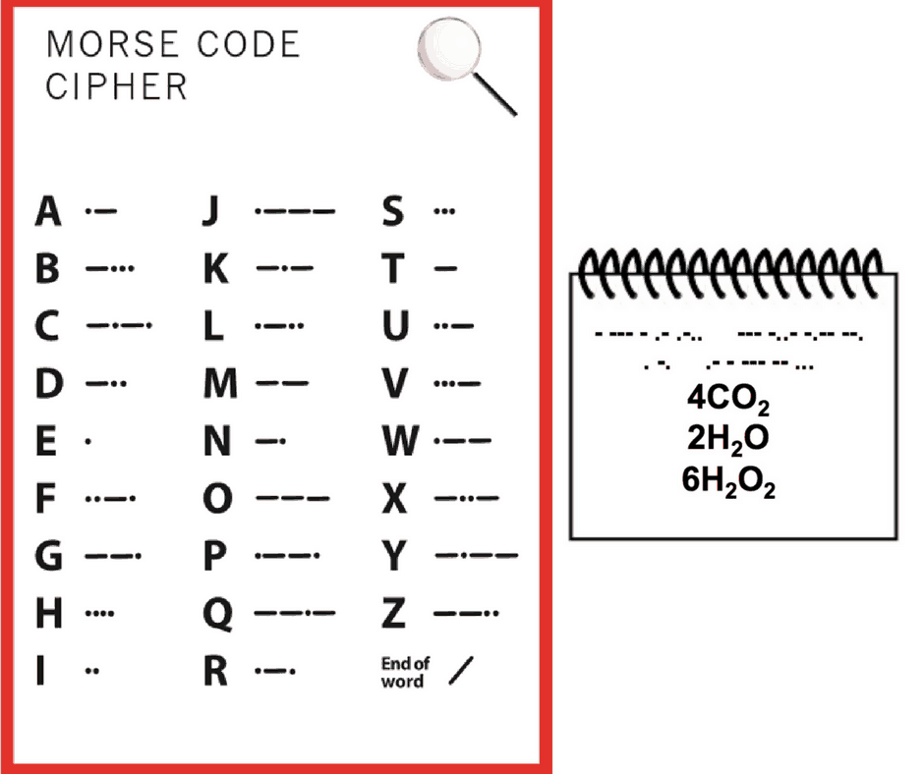 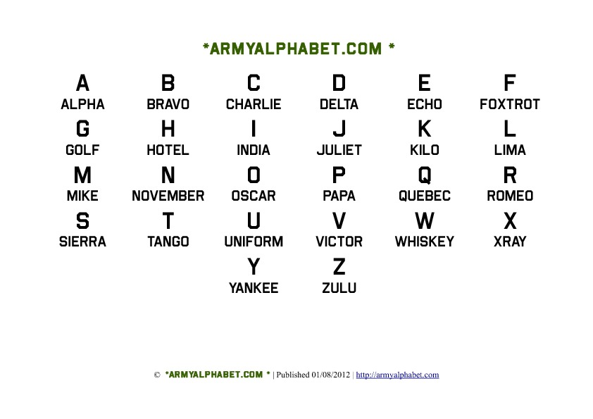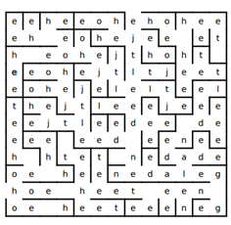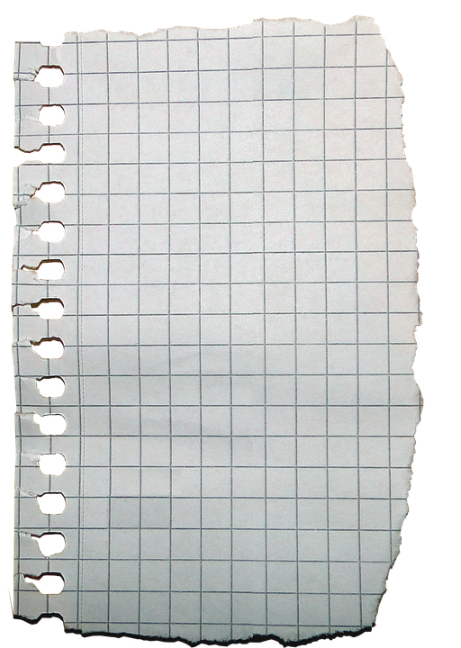

**Een element heeft altijd een symbool en een atoomnummer.**

**Chemici verbergen hun geheime stoffen dan soms ook met een code.**

**28 - 6 - 8 - 22 - 10**

**Nikkel - Koolstof - Zuurstof - Titanium - Neon**

**Ni - C - O - Ti - Ne**

**Nicotine**

**Secret Code**

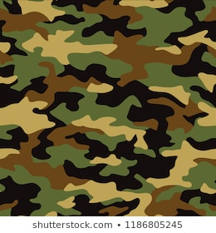

**NOVEMBER - INDIA - ECHO - TANGO**

**- ● ●-●● / ●●●● ● - / ●- ●- -● - ●- ●-●● /**

**-- ● - ●- ●- ●-●● -●●● ●● -● -●● ●● -● --● ● -●**

**-- ●● -●- ●**

**- ● ●-●● / ●●●● ● - / ●- ●- -● - ●- ●-●● /**

**-●-● --- ●●●- ●- ●-●● ● -● - ● /**

**-●●● ●● -● -●● ●● -● --● ● -●**

**- ● ●-●● / ●●●● ● - / ●- ●- -● - ●- ●-●● /**

**●● --- -● / -●●● ●● -● -●● ●● -● --● ● -●**

NaCL

KBr

Becl2

hcl

H2so4

h2O

LicL

Cas

Li2S

K3P

S8

CL2

CO2

H2S

MG

Drugslabo

|  |  |  |  |  |  |
| --- | --- | --- | --- | --- | --- |
| **Stoffen** | **Mol (n)** | **Massa (g)** | **Formule** | **Kleur** | **Vorm** |
| Stof A |  |  | C21H23NO5 | Geel | Vast |
| Stof B | 0,00310 | 1,0 |  | Wit | Vast |
| Stof C | 0,04124 | 8,0 |  | Wit | Vast |
| Stof D | 0,08889 | 12,0 |  | Licht geel | Vast |

|  |  |  |  |
| --- | --- | --- | --- |
| **Politielijsten legale en illegale stoffen Limburg en België** | | | |
| **Legale stoffen** | | **Illegale stoffen** | |
| **Gebruiksnaam** | **Molaire massa** | **Gebruiksnaam** | **Molaire massa** |
| Creatine | 131 g/mol | LSD | 323 g/mol |
| Nicotine | 162 g/mol | Cocaïne | 303 g/mol |
| Morfine | 285 g/mol | MDA | 179 g/mol |
| Ethanol | 46 g/mol | Speed | 135 g/mol |
| Cafeïne | 194 g/mol | Ketamine | 237 g/mol |
| Codeïne | 299 g/mol | DMT | 188 g/mol |
| Aspirine | 180 g/mol | Heroïne | 369 g/mol |
| Methadon | 309 g/mol | GHB | 104 g/mol |

Bindingenspel

MIC: (plakken op de doos)

Na, ik zoek een niet-metaal

O, ik zoek een metaal

Ca, ik zoek een niet-metaal

S, Ik zoek een metaal

O, ik hou van mezelf

O, ik wil dizuurstof worden

O, ik zoek een niet-metaal

2 x H, ik wil graag water worden

F, ik zoek iemand om elektronen van op te nemen

Mg, ik hou van mezelf

Fe, ik ben dubbel zo positief

Cl, ik zoek een metaal

Na, ik wil keukenzout worden

1 metaalbinding, 4 ionbindingen, 2 covalente bindingen

M : metaalbinding

I : Ionbinding

C : covalente bindingen

MIC

|  |  |  |  |
| --- | --- | --- | --- |
| http://www.sussexvt.k12.de.us/science/the%20history%20of%20the%20world%201500-1899/John%20Dalton's%20periodic%20tables_files/image004.jpg  Zuurstof  O | http://www.sussexvt.k12.de.us/science/the%20history%20of%20the%20world%201500-1899/John%20Dalton's%20periodic%20tables_files/image004.jpg  Waterstof  H | http://www.sussexvt.k12.de.us/science/the%20history%20of%20the%20world%201500-1899/John%20Dalton's%20periodic%20tables_files/image004.jpg  Stikstof  N | http://www.sussexvt.k12.de.us/science/the%20history%20of%20the%20world%201500-1899/John%20Dalton's%20periodic%20tables_files/image004.jpg  Koolstof  C |
| http://www.sussexvt.k12.de.us/science/the%20history%20of%20the%20world%201500-1899/John%20Dalton's%20periodic%20tables_files/image004.jpg  Zwavel  S | http://www.sussexvt.k12.de.us/science/the%20history%20of%20the%20world%201500-1899/John%20Dalton's%20periodic%20tables_files/image004.jpg  Fosfor  P | http://www.sussexvt.k12.de.us/science/the%20history%20of%20the%20world%201500-1899/John%20Dalton's%20periodic%20tables_files/image004.jpg  Goud  Au | http://www.sussexvt.k12.de.us/science/the%20history%20of%20the%20world%201500-1899/John%20Dalton's%20periodic%20tables_files/image004.jpg  Zilver  Ag  O |
| http://www.sussexvt.k12.de.us/science/the%20history%20of%20the%20world%201500-1899/John%20Dalton's%20periodic%20tables_files/image004.jpg  Kwik  Hg | http://www.sussexvt.k12.de.us/science/the%20history%20of%20the%20world%201500-1899/John%20Dalton's%20periodic%20tables_files/image004.jpg  IJzer  Fe | http://www.sussexvt.k12.de.us/science/the%20history%20of%20the%20world%201500-1899/John%20Dalton's%20periodic%20tables_files/image004.jpg  Calcium  Ca | http://www.sussexvt.k12.de.us/science/the%20history%20of%20the%20world%201500-1899/John%20Dalton's%20periodic%20tables_files/image004.jpg  Kalium  K |
| http://www.sussexvt.k12.de.us/science/the%20history%20of%20the%20world%201500-1899/John%20Dalton's%20periodic%20tables_files/image004.jpg  Natrium  Na | http://www.sussexvt.k12.de.us/science/the%20history%20of%20the%20world%201500-1899/John%20Dalton's%20periodic%20tables_files/image004.jpg  Magnesium  Mg | http://www.sussexvt.k12.de.us/science/the%20history%20of%20the%20world%201500-1899/John%20Dalton's%20periodic%20tables_files/image004.jpg  Barium  Ba | http://www.sussexvt.k12.de.us/science/the%20history%20of%20the%20world%201500-1899/John%20Dalton's%20periodic%20tables_files/image004.jpg  Strontium  Sr  r |
| http://www.sussexvt.k12.de.us/science/the%20history%20of%20the%20world%201500-1899/John%20Dalton's%20periodic%20tables_files/image004.jpg  Aluminium  Al | http://www.sussexvt.k12.de.us/science/the%20history%20of%20the%20world%201500-1899/John%20Dalton's%20periodic%20tables_files/image004.jpg  Silicium  Si  i | http://www.sussexvt.k12.de.us/science/the%20history%20of%20the%20world%201500-1899/John%20Dalton's%20periodic%20tables_files/image004.jpg  Yttrium  Y | http://www.sussexvt.k12.de.us/science/the%20history%20of%20the%20world%201500-1899/John%20Dalton's%20periodic%20tables_files/image004.jpg  Beryllium  Be |
| http://www.sussexvt.k12.de.us/science/the%20history%20of%20the%20world%201500-1899/John%20Dalton's%20periodic%20tables_files/image004.jpg  Zirconium  Zr |  |  |  |

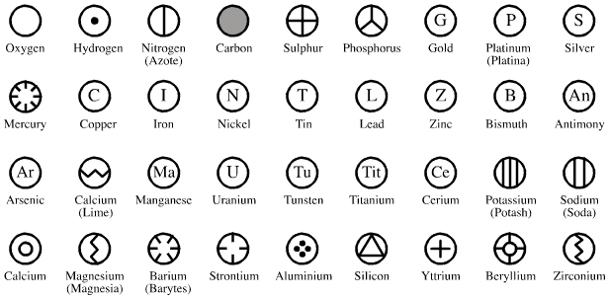





G