Brandende zakdoek

Onderzoeksvraag
Hoe komt het dat het briefje niet verbrandt?

Hypothese
……………………………………………………………………………………………………………………………………………………..
……………………………………………………………………………………………………………………………………………………..
……………………………………………………………………………………………………………………………………………………..
……………………………………………………………………………………………………………………………………………………..

Materiaal
-ethanol-water (50-50)
-zakdoek of bankbiljet
-metalen tang
-lucifers

Veiligheidsetiketten

Ethanol
CH3CH2OH
CAS
64-17-5
Gevaar
H 225 Licht ontvlambare vloeistof en damp.
P 210 Verwijderd houden van warmte/vonken/open vuur/hete oppervlakken. — Niet roken.
WGK 1 | Mr: 46,07 | Mijn school

Uitvoering
Dompel de droge zakdoek in de alcohol-wateroplossing. Wring uit.
Steek de bunsenbrander aan.
Houd de zakdoek of bankbiljet met behulp van de tang in de vlam.
Doof de vlam door met de tang te schudden van zodra de vlam vermindert.

Opstelling

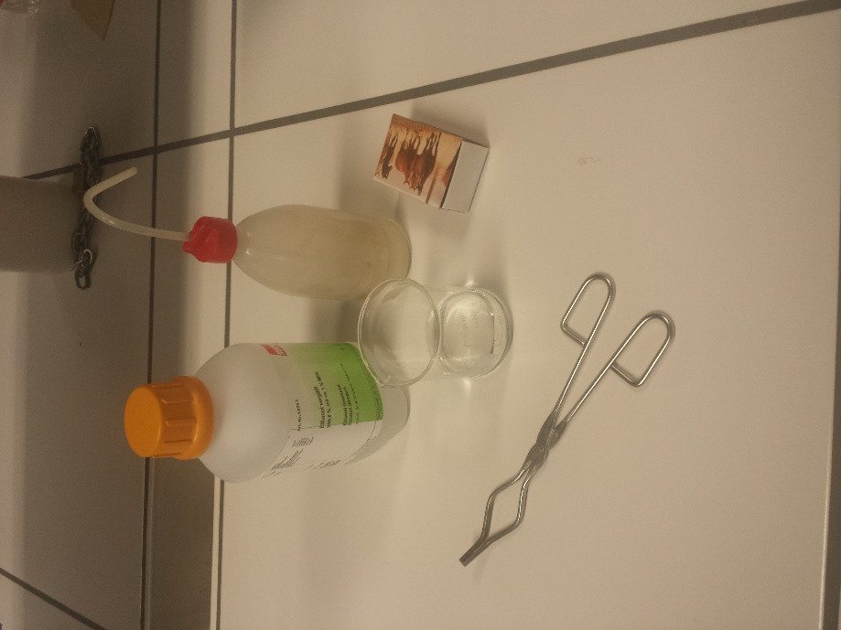
Waarneming

……………………………………………………………………………………………………………………………………………………..
……………………………………………………………………………………………………………………………………………………..
……………………………………………………………………………………………………………………………………………………..
……………………………………………………………………………………………………………………………………………………..

Conclusie
……………………………………………………………………………………………………………………………………………………..
……………………………………………………………………………………………………………………………………………………..
……………………………………………………………………………………………………………………………………………………..
……………………………………………………………………………………………………………………………………………………..

